**Pre-workout Snacks** (Eaten 30- 90 minutes prior to practice or lifting)

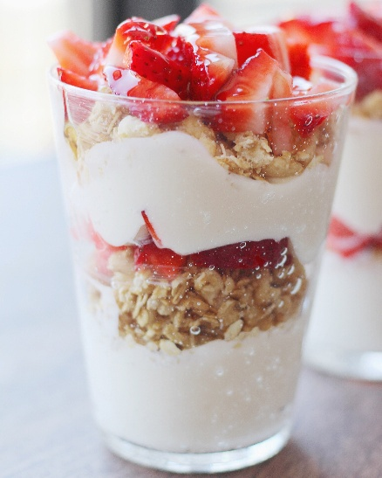 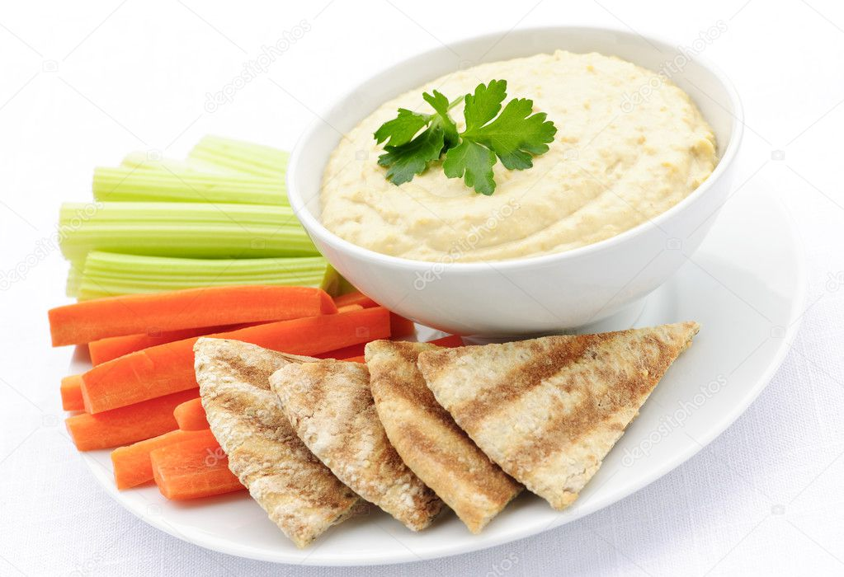 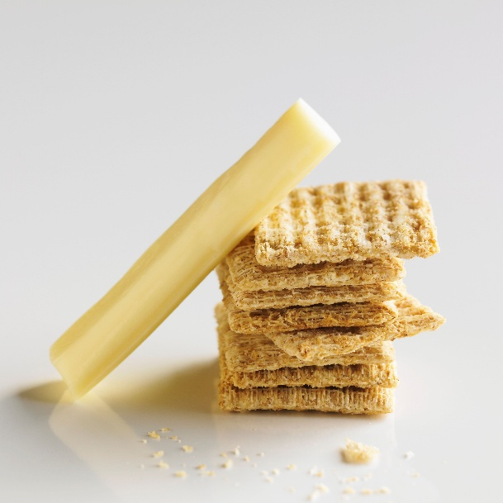

**Greek yogurt with granola Hummus with pita bread & veggies String cheese and crackers**

**& fruit**

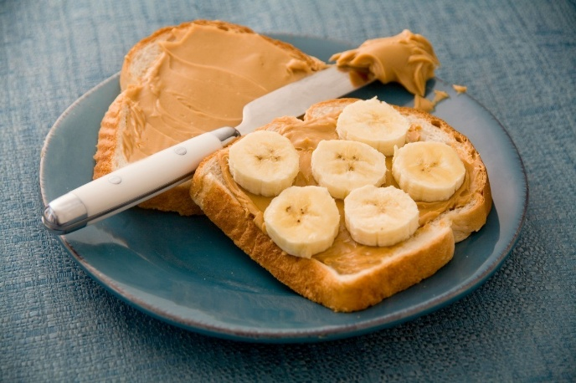 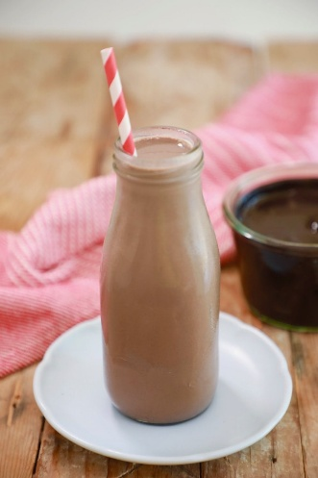 

**Toast with peanut butter & banana Chocolate Milk Juice (any) & egg with toast**

**or (other fruit)**

**Post-Workout Snacks** (Eaten 30 – 60 minutes post practice or workout)

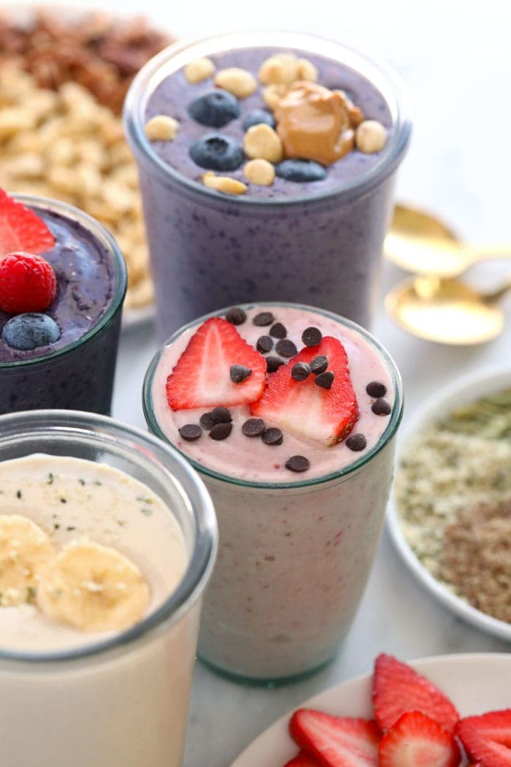 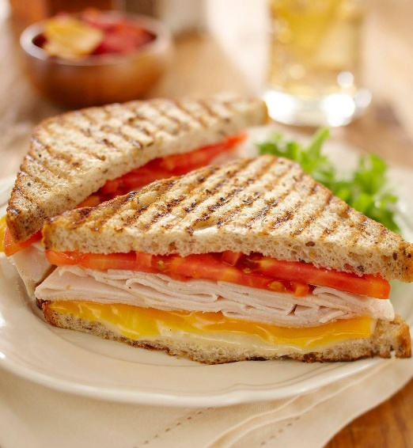 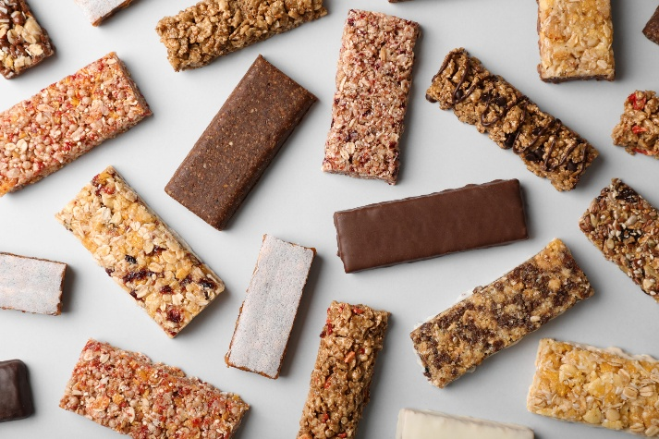

Protein Shake/Smoothie Turkey & Cheese Sandwich Protein Bar & piece of fruit/ handful (any)

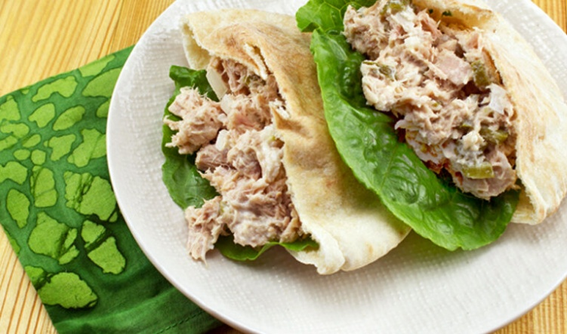 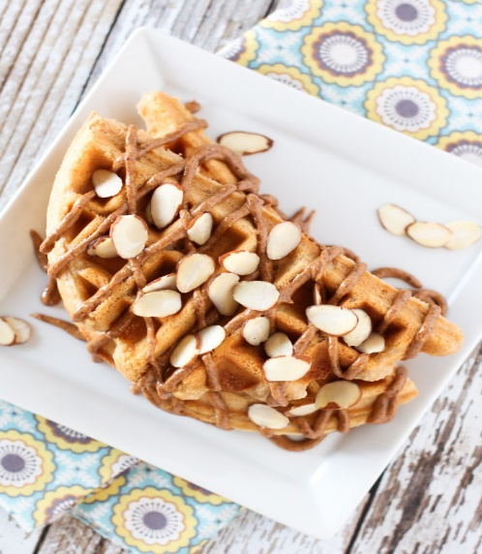 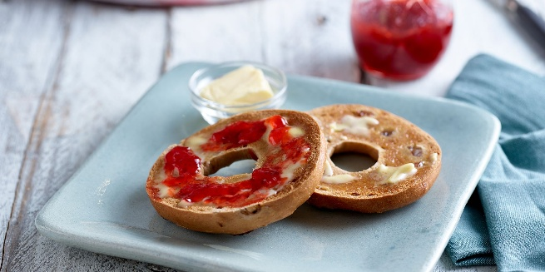

Tuna Salad in Pita bread Protein Waffle with Almond butter Bagel with Jelly